**Sunkari Manohar**

**Assessment 1 – 28/12/2023**

Today we started with introduction to Azure Data Bricks and allotted the Azure Data Bricks account.

**Make My Labs dashboard:**

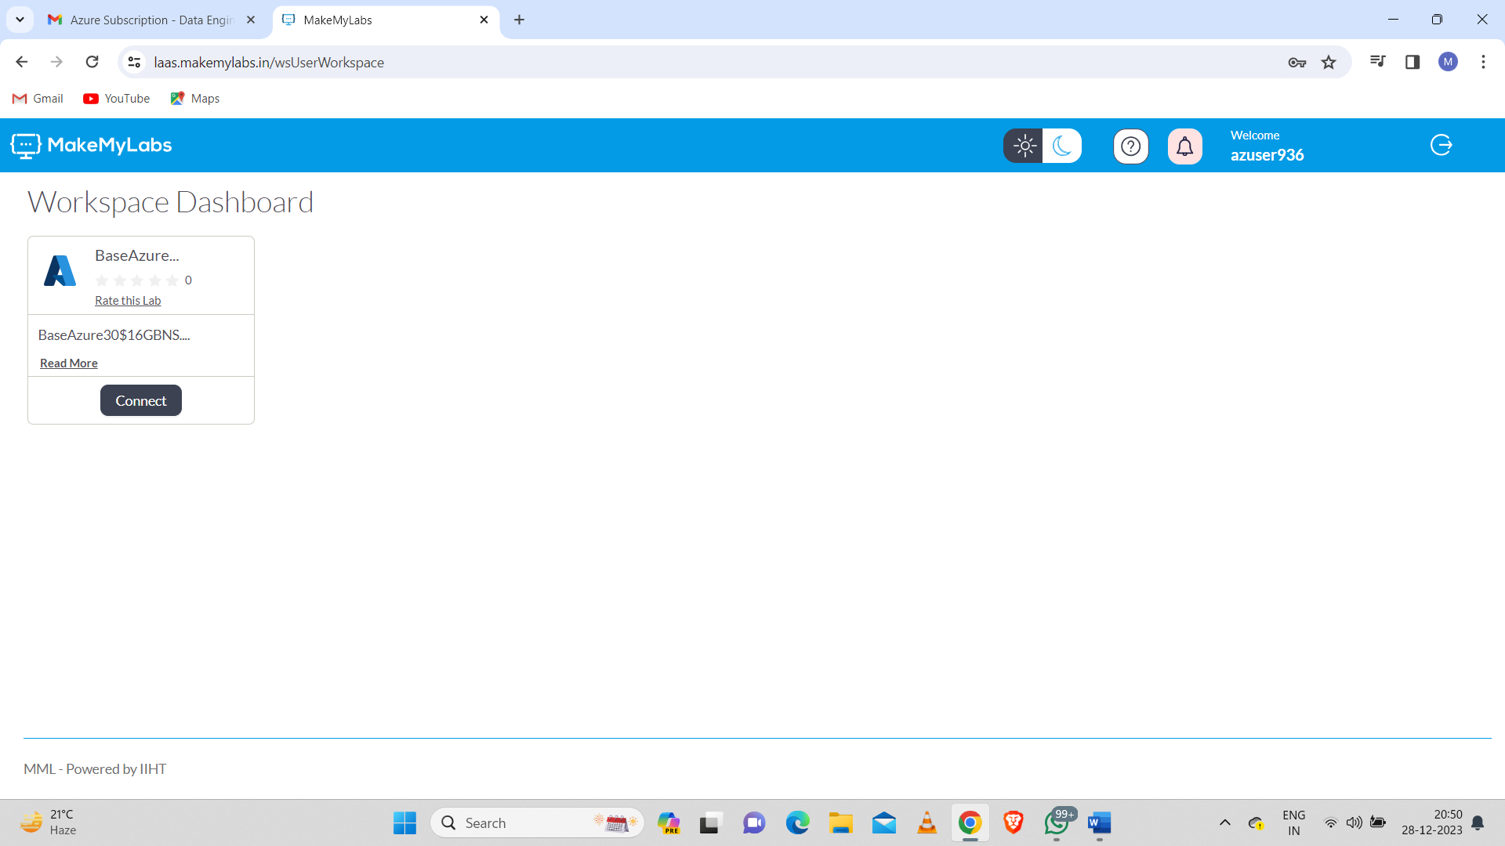

Later we need to click on connect button then there will find Authentication URL to access Microsoft Azure portal with username and temporary access password

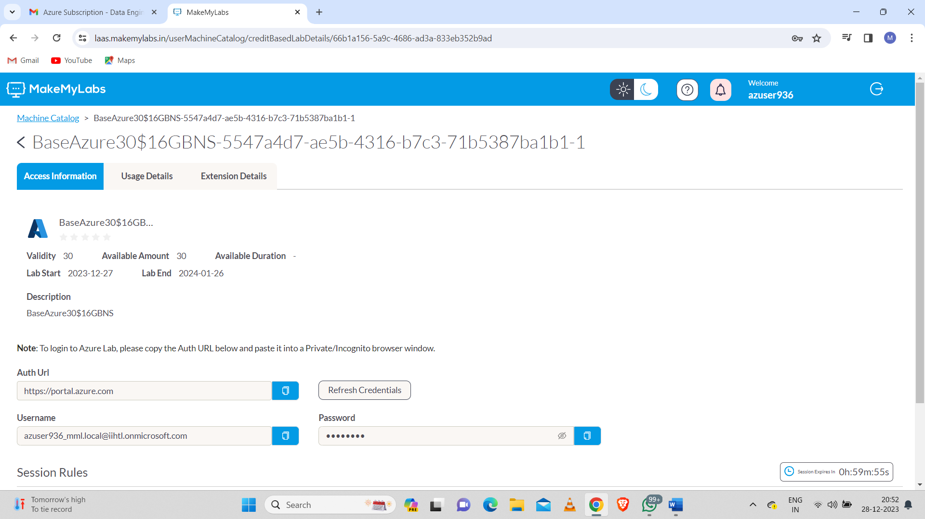

Then by pasting the authentication url in another tab to open Microsoft azure portal using username and temporary access password:

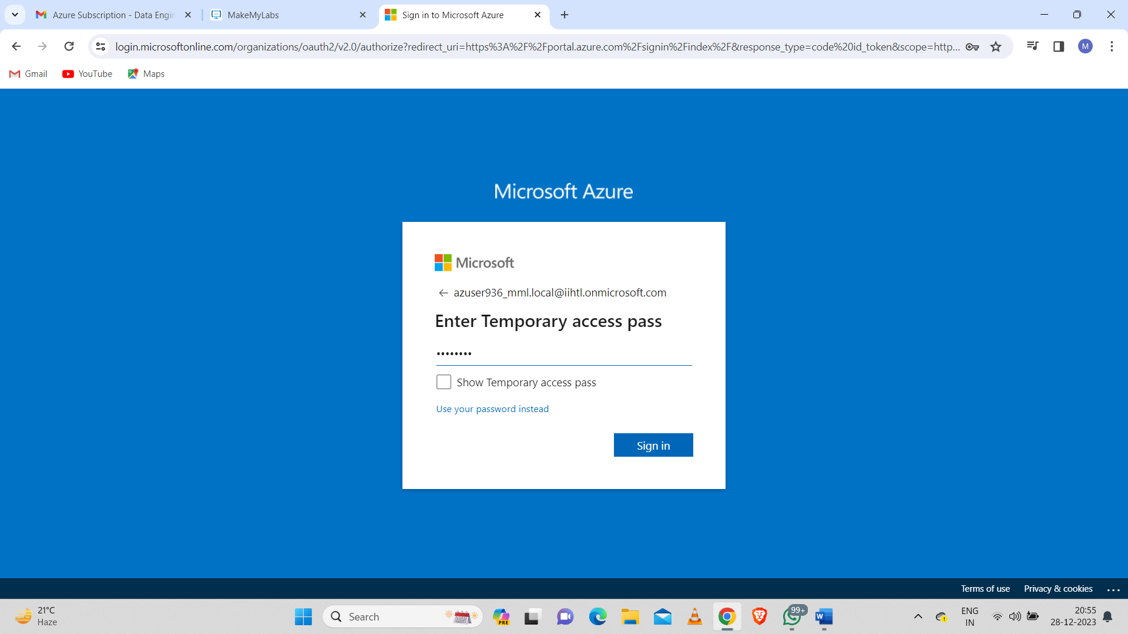

Click on Sign in button to access the Microsoft azure portal.

Azure Dashboard:

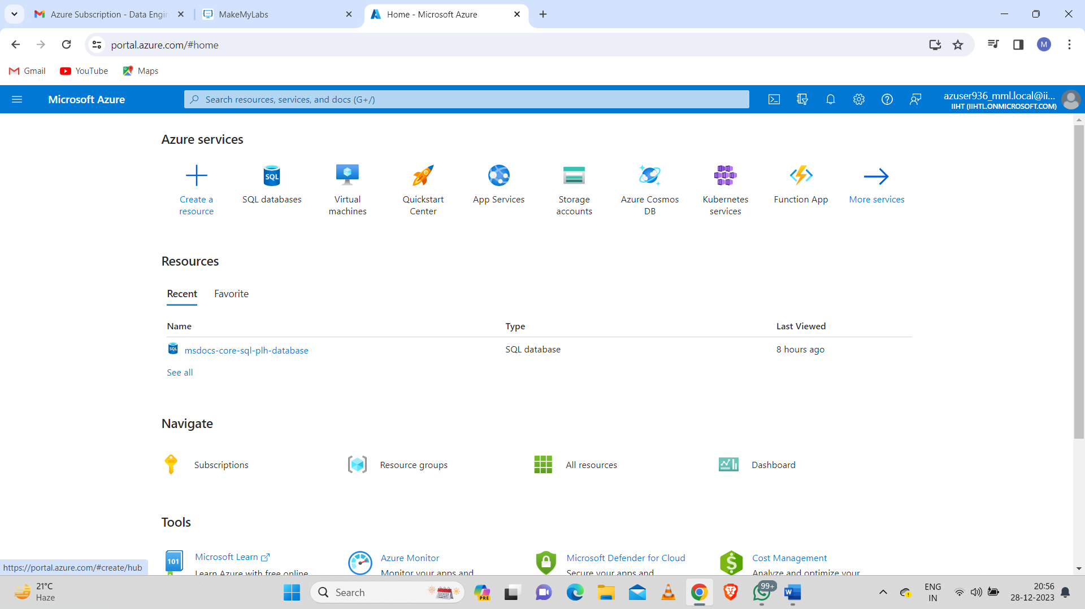

**Introduction to Azure Databricks:**

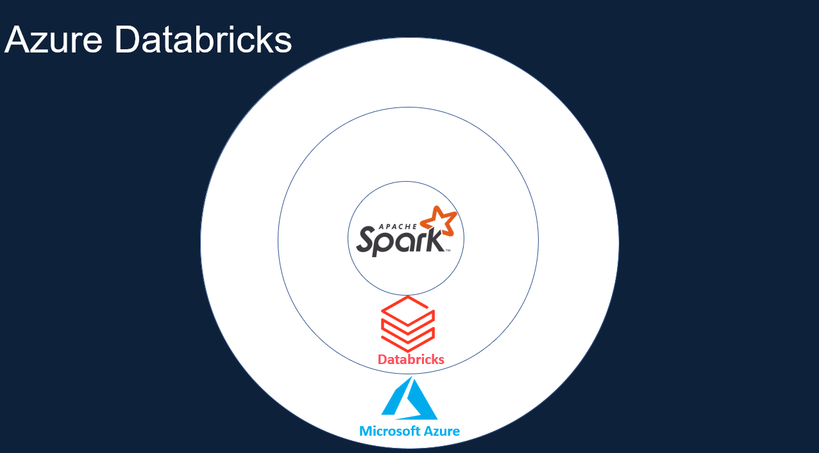

**Apache Spark:**

Apache Spark is a lightning-fast unified analytics engine for big data processing and machine learning.

**Apache Spark Architecture:**

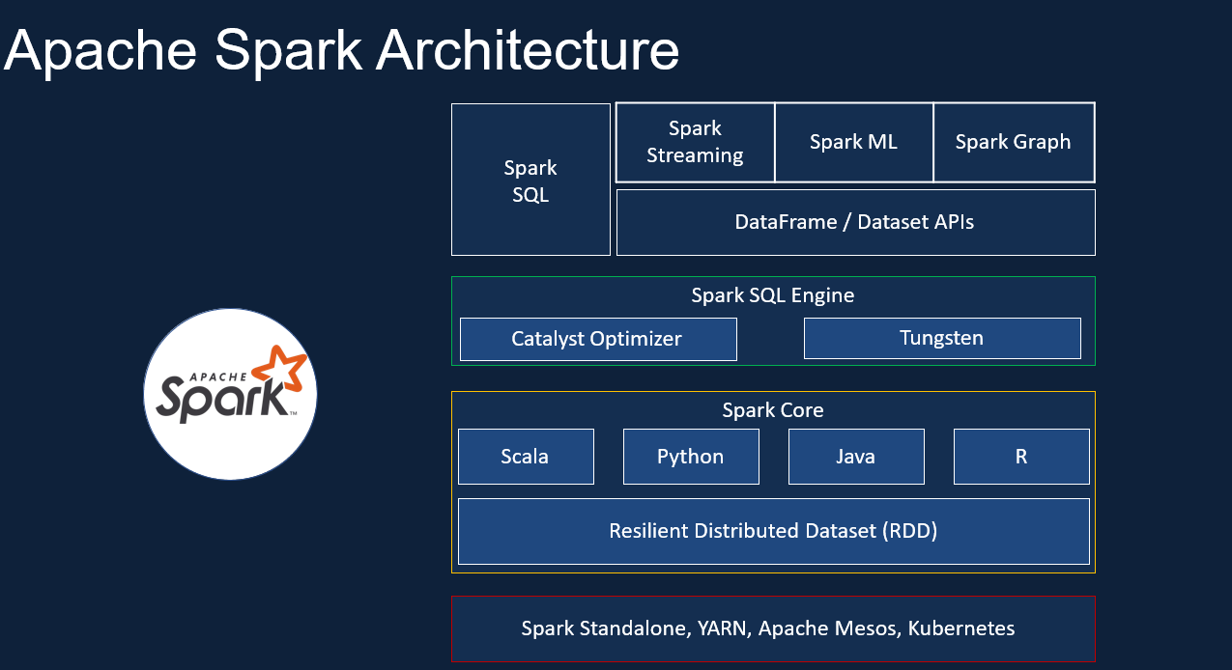

**Databricks:**

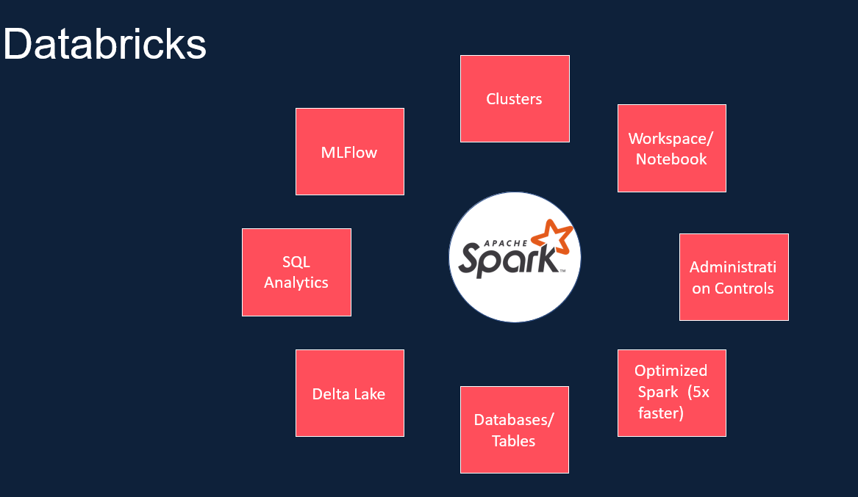

**Azure Databricks:**

